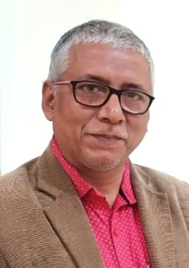

Dr. Raj Kumar Mazinder

Studied B- Fine in Visual Arts at Kala Bhavana, Santiniketan in painting (1985-1990) and M. A (Fine) Faculty of Fine Arts, M. S. University of Baroda in graphic arts, 1992 and Doctor of Philosophy (Ph. D) in Visual Arts from Assam University, Silchar 2015 Exhibited extensively in India and abroad since 1990. Awarded “Europe Art Tour” of Paris, Venice, Florence and Rome in All India Art Exhibition 2014 and Eastern Region Art Exhibition at Academy of Fine Arts, Kolkata organized by Camel Art Foundation, Mumbai and exhibited his paintings at 7th Barat Bhavan Biennial of Contemporary Indian Art, 2017 at Bharat Bhavan, Bhopal. Wrote several writings on art and aesthetics in reputed ISSN Journals and included in books of eminence as well***.*** His book on art titled “*Shilpokala:Oitihya aru Adhunikota*” in Assamese language has been published by N. L. Publications, Guwahati in 2017. Presently lives and teach as Head i/c and Assistant Professor at Department of Visual Arts, Assam University, Silchar.