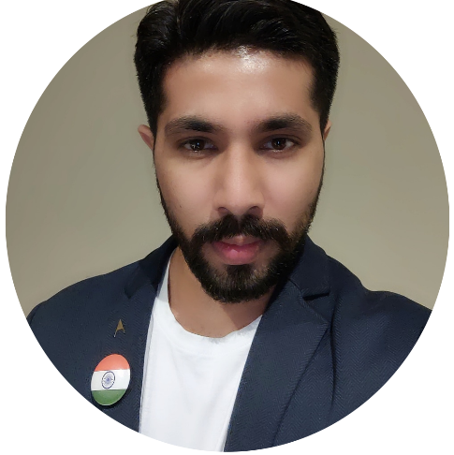**Rao Ranveer Kumar**

Born September 9, 1988

New Delhi, Delhi (India)

2015 B.F.A. Sir J.J. School of Art, Mumbai (Maharashtra)

2010 B.Des. National Institute of Fashion Technology, Delhi

**Solo Shows**

2019 Vision of the Beauty, Jehangir Art Gallery, Mumbai

**Group Shows**

2020 Art35, Nine Fish Art Gallery, Mumbai, India

2019 The Expopedia, Cymroza Art Gallery, Mumbai, India

**Art Fairs**

2020 World Art Dubai, United Arab Dubai

2020 Indian Art Festival, Mumbai, India

2019 Qatar International Art Festival, Doha, Qatar

**Residencies & Awards**

2019 Artists Excellence Award, Doha, Qatar

2018 National Art Camp, Uttrakhand, India

2016 National Art Camp, Mumbai, India

2014 Award for Photography, Monsoon Camp, Mumbai, India

**Participation**

2015 Kalamela Sir J.J. School of Art, Mumbai, India

2014 Kalamela Sir J.J. School of Art, Mumbai, India

2013 Monsoon Art Festival, Sir J.J. School of Art, Mumbai, India

2013 Kalamela Sir J.J. School of Art, Mumbai, India

2012 Kalamela Sir J.J. School of Art, Mumbai, India

**Publications**

2019 Artmosphere, Crisol Art Gallery, Barcellona, Spain

2019 Gulf Times, Doha, Qatar

2005 Navbharat Times, Delhi, India

2004 Hindustan Times, Delhi, India

2003 Hindustan Times, Delhi, India